

## Unlock Peace of Mind With Our Services

Streamlined Services Tailored to Your Business Needs

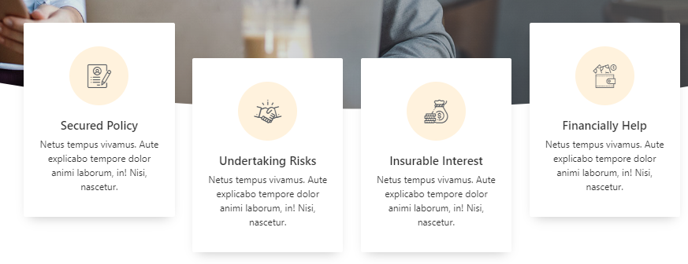

## "Personalized Payroll Management"

We understand that every business is unique. That's why we offer tailor-made payroll solutions designed to fit your specific needs.

## "The Best Bookkeeping"

In the realm of Bookkeeping management, precision is paramount, we raise the bar by delivering unparalleled bookkeeping services designed to elevate your business operations.

## "Swift and Sufficient"

Our team is dedicated to providing you with solutions that are not only fast, but also easy to navigate.

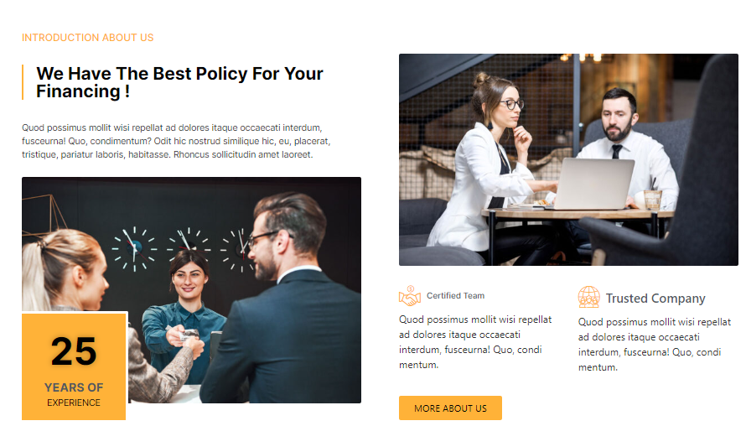

We Offer Incredible Bookkeeping and Payroll Management!

Our comprehensive services cover both bookkeeping and payroll management, providing you with the tools and support you need to drive success. With a team of dedicated professionals, we deliver exceptional results that exceed expectations.

**Certified Team**

Trusted experts dedicated to your success. Meet our certified team for unparalleled expertise and support

**Trusted Company**

Reliability you can count on. We're your trusted partner, committed to securing your success and prosperity.

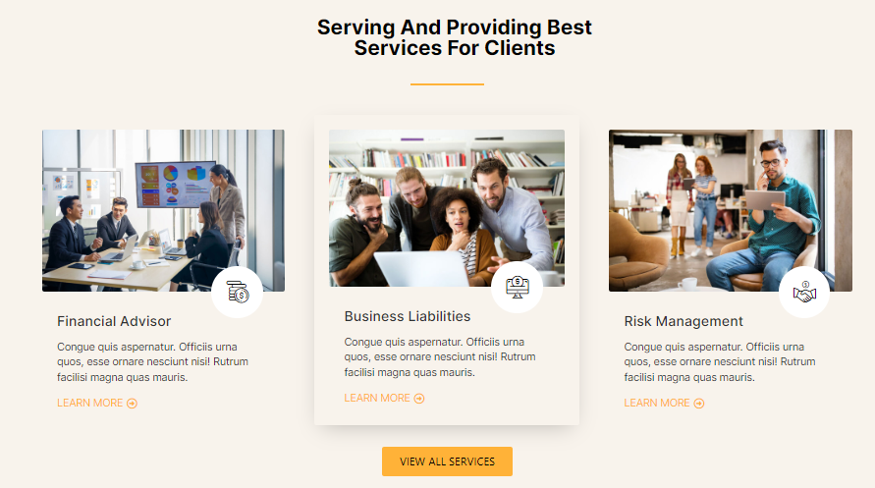

**Business Scalability**

Outsourcing critical functions allows you and your team to concentrate on what you do best—growing your business, developing products, and serving customers.

**Business Liabilities**

Mitigate risks and protect your business. Our expertise in handling liabilities ensures your payroll security and sustained growth

**Bookkeeping for Success**

With precise bookkeeping, you gain a clear view of your business's health. This empowers you to make informed decisions, identify growth opportunities, and manage cash flow effectively.



## We Offer Only the Best

Embark on a journey of excellence with us. Our unwavering dedication to providing top-notch services ensures your business thrives. Don't settle for less, hire the best for your success.

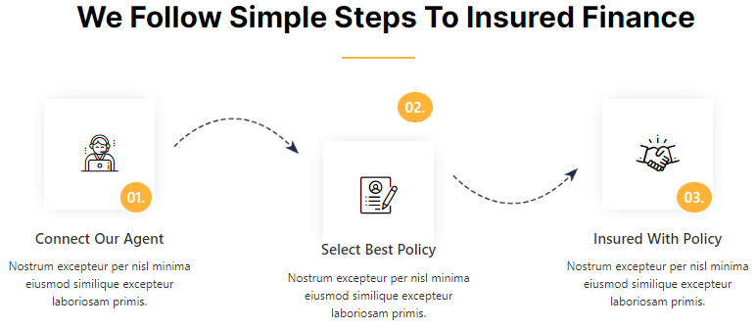

**Step 1: Connect with Our Agent** Begin your journey by reaching out to our experienced agents. They're here to guide you through every step, answering questions and tailoring solutions to your unique needs.

**Step 2: Select Your Preferred Service** With expert advice at your disposal, choose a service that aligns perfectly with your business goals. Our diverse range ensures you have options that cater to your specific requirements.

**Step 3: Enjoy Efficiency**

Once you've made your selection, our streamlined process ensures quick and hassle-free coverage. Enjoy peace of mind knowing your accounts are protected with a service designed just for you.



"Ready to secure your future? Provide us with some details, and let's tailor a quote that fits you perfectly.

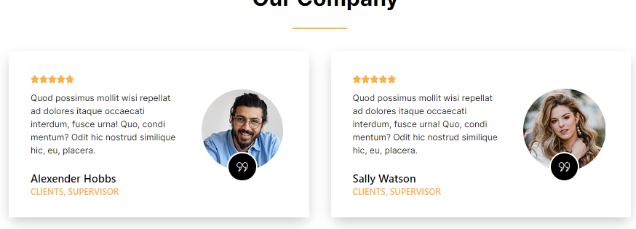

**Testimonial 1:** “EDULINK Group has been an invaluable partner for our institution. Their comprehensive solutions and expert advice have propelled our growth and stability in the education sector.”

**Testimonial 2:** “Partnering with EDULINK Group has transformed our business. Their team's dedication to our success and deep industry knowledge is truly commendable. A game-changer for us!”



Welcome to our news and insights hub, where we share valuable industry knowledge, trends, and updates to keep you ahead of the curve. Explore our latest articles, reports, and expert opinions below.

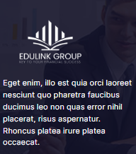

EDULINK Group leads the way in providing specialized payroll management and bookkeeping services. With an in-depth understanding of distinctive needs, we offer tailored solutions to ensure seamless operations.

## About Us PAGE



## We have the best Procedures for your Bookkeeping and Payroll!

Welcome to EDULINK Group, where we specialize in top-tier payroll management and bookkeeping services. With a dedicated team of certified experts, we're committed to delivering unparalleled solutions that promote growth and prosperity.

**Our Certified Team**

Our strength lies in our team of certified professionals, each possessing a wealth of experience in Bookkeeping and Payroll Management. With a deep understanding of industry intricacies, we provide tailored solutions that ensure stability and growth.

**Trusted Company**

At EDULINK Group, trust is the cornerstone of our operations. For years, we've built a reputation as a reliable partner for educational institutions, offering steadfast support and innovative solutions. Our track record speaks volumes about the trust our clients place in us.

**Our Mission**

Our mission is to excel in providing unparalleled payroll management and bookkeeping services, ensuring progress and efficiency. We're dedicated to offering solutions that contribute to the seamless operation of your business, creating a solid foundation for the future.

**Our Vision**

We envision a future where every business, regardless of size or location, can rely on expert payroll and bookkeeping services. Through our specialized expertise, we aim to set a new standard in accounting services, making it more accessible, efficient, and conducive to growth.

## Services Page

**Payroll Services**

Efficient payroll management is crucial for any educational institution. At EDULINK Group, we streamline your payroll processes, ensuring timely and accurate payments to your staff. Our expert team handles payroll calculations, tax withholdings, and compliance with industry regulations.

**Bookkeeping Solutions**

Accurate records are the bedrock of sound decision-making. Our specialized bookkeeping services guarantee meticulous tracking of income and expenses, enabling you to maintain a clear picture of your accounts.

## Contact Page

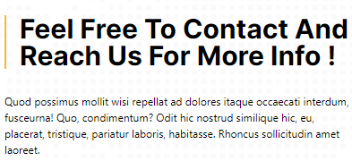

Questions? Need expert advice? We're here to help. Feel free to reach out to our dedicated team. Your success is our top priority.

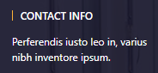

Feel free to reach out anytime anywhere!